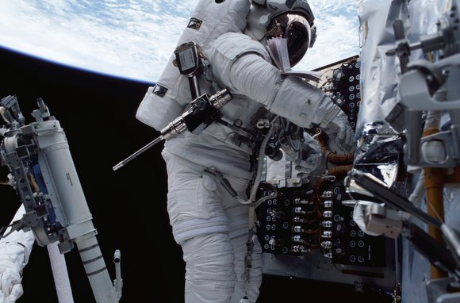

Practicing for repairs in space

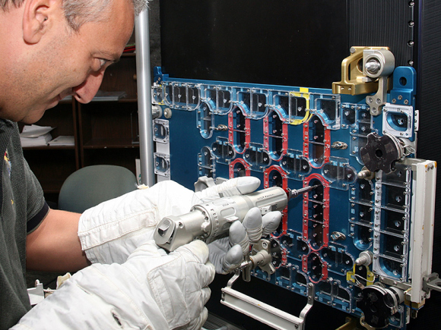

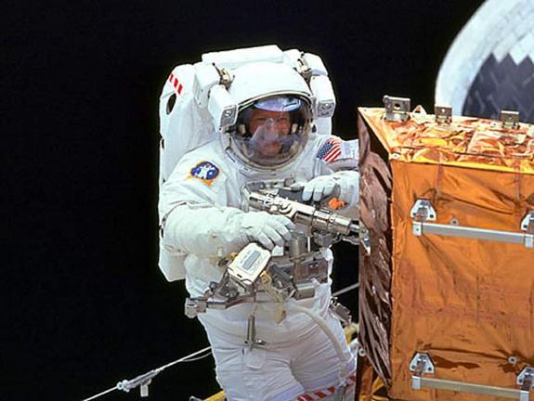

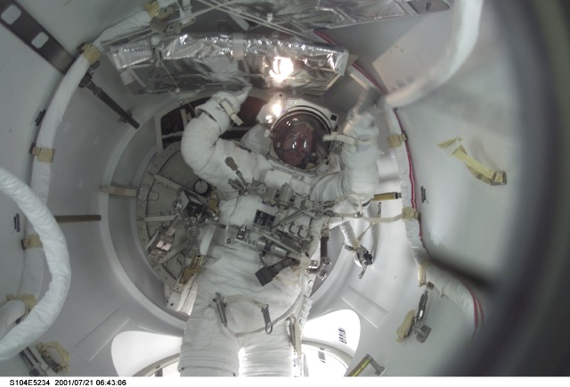

Page 123 - <http://www.nasa.gov/centers/johnson/pdf/584725main_Wings-ch3d-pgs110-129.pdf>